Kemble Cinema

Student Name: Luke Hammond
Student Email: luke2.hammond@live.uwe.ac.uk
Student Number: 21013675
Module Title: Marketing Strategy
Module Code: UMKDWA-15-M
Assessment Title: Kemble Cinema

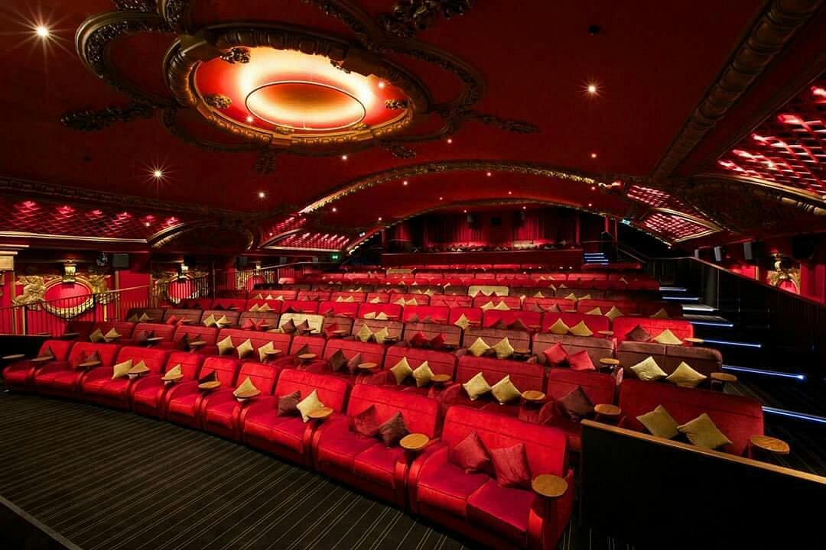

Keywords: Kemble Cinema, Competitive Advantage, Blue Ocean, SWOT, Brand Equity Model, Positioning, Marketing Audit, Microenvironment, Macroenvironment, Mesoenvironment, Segment

Question 1
Using relevant theories, frameworks, and concepts, analyse and evaluate the current position in which Kemble Cinema finds itself and make recommendations for a marketing strategy. Identify any risks or challenges associated with your recommendations.

Kemble Cinema (Current)
Kemble Cinema finds itself in a mass market dominated by a few competitors in which it aims to replicate their successes; displaying big blockbuster movies which lack the same quality that can be found at one of these multiplex chains making Kemble Cinema a Market Follower in a red ocean (Kim & Mauborgne, 2004).
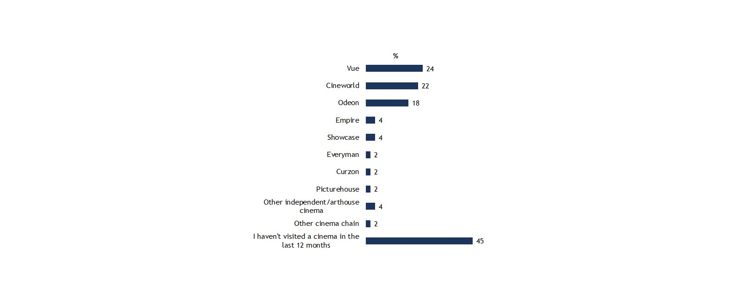
Figure 1 - Cinema Visits in 2022
However, as demonstrated by the SWOT analysis, it lacks the qualities of its competitors while charging a higher price, and lack of onsite parking adds to this image of an expensive and underwhelming experience. In the market of cinema this is an unfortunate position in the current climate which can be closer analysed following the marketing audit.
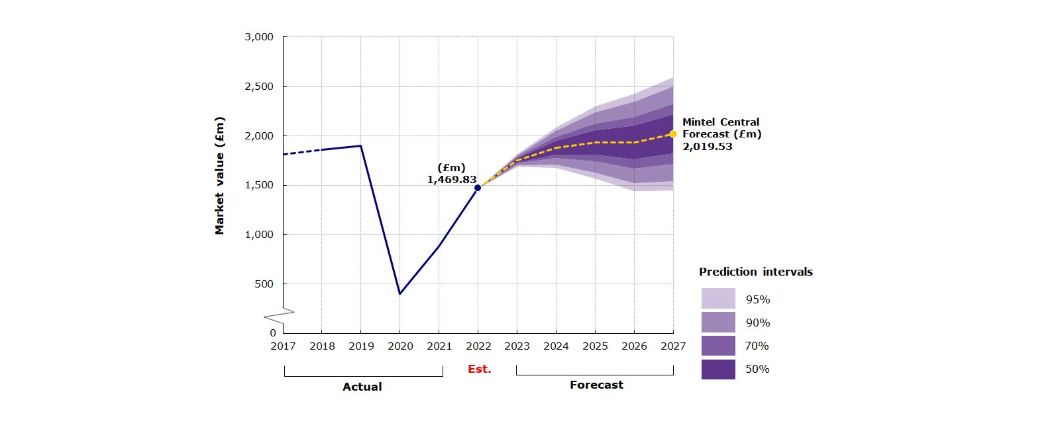
Figure 2 - UK Cinema Market Value
Still recovering from the COVID-19 pandemic, cinema market sales are below what they once were, and estimates are only rivalling their past results. This lack of market drive can be pinpointed to a few factors, one significant factor is the cost-of-living. Consumers are less likely to spend their money on expensive and mediocre experiences due to cutting back on leisure spending.
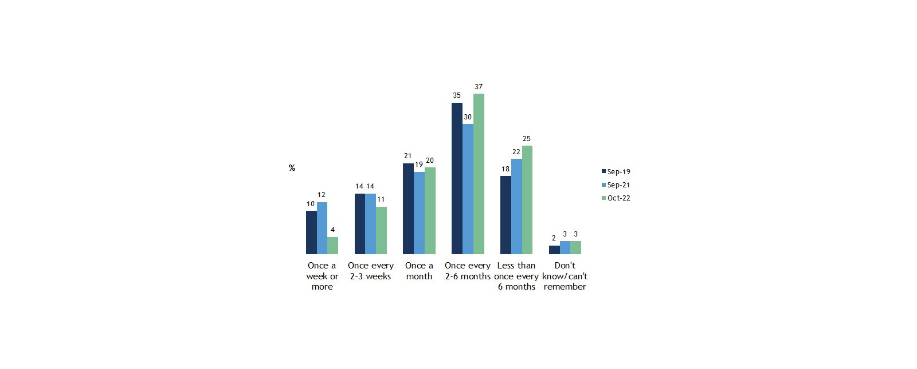
Figure 3 - Frequency of Cinema Visits, 2019-22
This has led to a decrease in customer frequency which accompanied by market leaders having a strong hold on the percentage of people attending screens results in smaller services like Kemble Cinema to suffer more significantly. Furthermore, Bristol is a city full of powerful multiplex cinema chains which are slowly buying specialised in art house films, accumulating most of the possible viewing spots.
Additionally, with the lack of blockbuster movies being released, especially following the pandemic, Cinemas have not been able to draw customers in as much, paired with rising ticket prices due to inflation, many have very little reason or push to attend. Moreover, external services such as video streaming services are now acquiring movies shortly after cinema release, making the traditional 17 week ‘theatrical window’ a thing of the past reducing possible revenue of blockbuster movies in cinema as they premiere for a shorter amount of time.
However, despite all of this, if someone were to spend money to attend the cinema, a significant percentage are not likely to purchase food or drinks from the cinema. While most cinema goers buy their food and drink in the cinema, 23% buy their food and drink somewhere else and bring it in. This is a present problem for Kemble Cinema who estimate 25% of food and drinks consumed on site is not purchased from themselves, 2% higher than the industry. Ultimately, this results in a big loss of revenue for one of their biggest differentiating points, their bar and café.
Additionally, due to Kemble Cinemas lack of social media presence and poor website, it can be assumed that it is not likely customers can purchase a seat online. This has a big impact on a user’s journey to purchase a ticket as they will have to purchase in-person which we have established is difficult to accomplish due to the lack of onsite parking. More significantly, booking in advance online is the most popular method of purchasing tickets… 42% used a cinema website the last time they went to the cinema (Mintel, 2022). Knowing this information as well as the largest portion of cinema goers being the younger generation of 25 and under, who are one of the biggest consumers of the web and social media (Ofcom, 2024), it is clear that Kemble Cinema is missing out on the biggest audience available to them.
The current position of Kemble Cinema is a cinema that provides great customer service to those wanting to watch the latest releases. A further breakdown can be demonstrated through Keller’s Brand Equity Model.
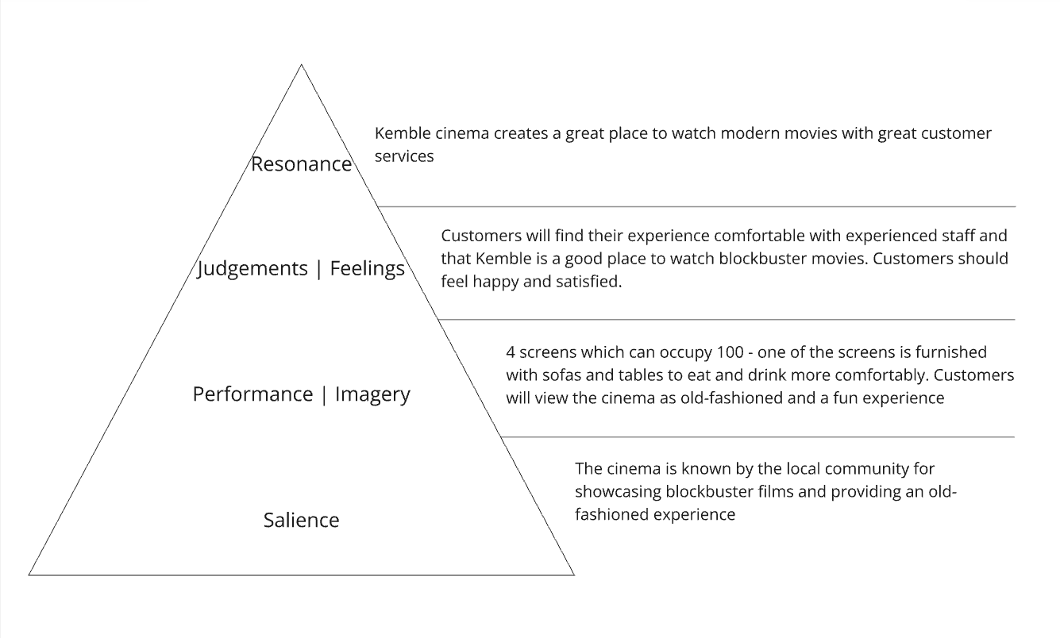
Figure 4 - Keller's Brand Equity Model of Kemble Cinema (Current)
Identifying how the current brand positioning fits into the cinema market will allow the identification of the current strengths and weaknesses as shown in the SWOT analysis. Kemble Cinema currently resides within a red ocean where its Microenvironment is not utilised effectively to differentiate itself within the sector. As the performance/imagery states in the figure above, the cinema has four screens which can occupy one hundred, that is a small number of screens in comparison to competitors and while the cinema is perceived as ‘old-fashioned’, this is currently a detriment as the biggest market audience is the younger generation who are not willing to visit such an ‘old-fashioned’ cinema. However, while the ultimate result of this performance is the positive feelings customers will experience, the lack of uniqueness does not leave a lasting memory for consumers, thus their judgments of the experience are simple and not one that would resonate with a consumer.
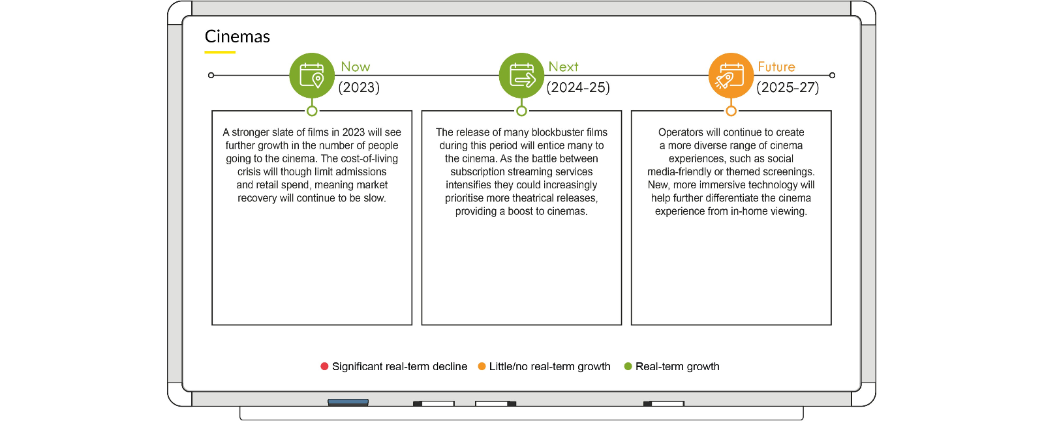
Figure 5 - Category Outlook for Cinemas, 2023-27
The current prediction for the market is differentiating yourself within the saturated market an example of a blue-ocean approach. Outside of exclusive releases the primary selling point of the cinema is the different experience it provides to watching at home (Mintel, 2022). Established in the SWOT and the marketing audit, Kemble Cinema has unique resources not commonly found elsewhere, especially in the multiplexes. Kemble Cinema has the equipment for 35mm and 70mm film projection which resonates with its ‘old-fashioned’ 1938 Art Deco Style interior. This provides an opportunity for a uniquely old experience, which is evidently popular as seen with the recent resurgence of vinyl records. By utilising the strength of their equipment, they can take an ‘inside-out’ strategy by establishing a superior performance through their non-substitutable resources (Barney, 1991); cinemas need to provide greater diversity of experiences to attract a broad audience (Mintel, 2022). This approach can aid in developing Kemble Cinema into a blue-ocean company, one that pursues that uncontested space in the saturated red-ocean market that is cinema.

Kemble Cinema (Recommendation)
For Kemble Cinema to increase their sales they will need to develop a competitive advantage by achieving a better experience than the other competitors (Davidson, 1987). Developing a competitive advantage will need to be attained through an offensive bypassing strategy that enables Kemble Cinema to differentiate itself from the competitors that customers value and that commands a price premium (Porter, 1980). As seen in Figure 5 a blue-ocean company that pursues an opening in the market will be the cinema experiences that excels in the coming future. Therefore, developing such an environment will move Kemble Cinema from a Market Follower into a Market Niche that will command presence and attention in the world of cinema.
Kemble Cinema currently struggles to attract the younger generation so it will instead segment its market to generationally (Tonks, 2009). Data shows an increase in cinema visits from Gen X, followed by Baby Boomers and the Swing Generation especially during the period of September 2021 and October 2022 (Mintel, 2022). These are most likely linked to the nostalgic presence of films such as Top Gun: Maverick and the biopic Elvis movie. Both movies had enough draw to bring back older audiences who were largely avoiding going to the cinema (Mintel, 2022). Thus, Kemble Cinema will focus on the older generation who will reminisce and resonate with the nostalgia of an art deco styled cinema and appreciate watching classics in the environment.
Therefore, following the combined Strengths and Opportunities identified in the TOWS, Kemble can produce a unique service, reminiscent of the resurgence of vinyl, that enables consumers to achieve a nostalgic buzz through viewership of past movies shown on the classic 35mm and 70mm video projection. Coinciding with the Growth Strategy Matrix developed by Ansoff in 1965, Kemble Cinema will be introducing a new product/service into the existing market. Utilising pre-existing equipment and technical skills to innovate the cinema experience can aid in Kemble Cinema creating the greatest source of a competitive advantage (Kozlenkova, et al. 2013). Older generations will likely embrace films with an affection for the past… as nostalgia can be a source of comfort and reassurance (Mintel, 2022) which will be what cinemas aim to provide with the rise in cost-of-living as stated previously. Previous instances of recession/income squeeze suggest cinema will not be heavily affected due to it being perceived as good value for money and an opportunity for consumers to escape from the busy world, in this case through a means of nostalgia.
Moreover, another resource of Kemble Cinema which will be reimagined is their bar and café, both occupied by great customer service from experienced staff who have been with the company for many years. The bar and café will provide a position defence strategy offering time-limited novelty or themed food and drinks based on the classic films being shown to reduce external food and drink consumption. These promotion activities will enhance the escapist feel cinema provides as well as embrace the fan culture of the airing classic movies to increase the immersion for the target audience.
Considering the proposed change in target market and new product attributes, Kemble Cinema will be undertaking a Total Repositioning (Ling, 2024). This is crucial to Kemble Cinemas future success as the positioning of the company which will soon occupy a competitive advantage with the changes, need to establish a distinct competitive position in the target consumers mind (Kotler, et al. 2010). The new brand position can be seen in the figure below.
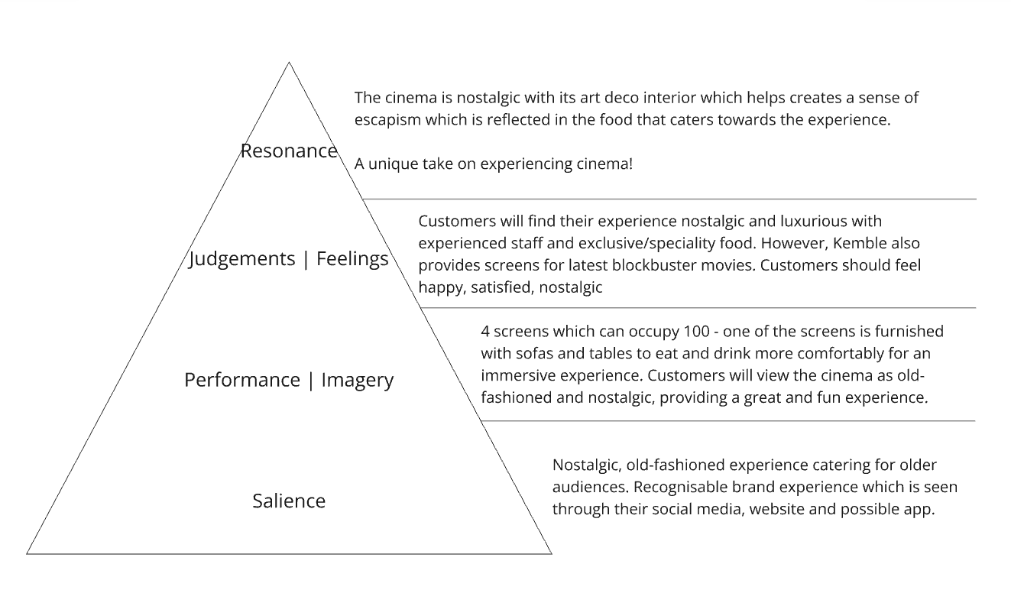
Figure 6 - Keller's Brand Equity Model of Kemble Cinema (Recommended)
Kemble Cinemas salience will be a nostalgic blast from the past with their art deco style interior which is perceived as ‘old-fashioned’ which will suit the target demographic. Seamless user experience with customer service as well as an easy-to-use website, that will require updating, will add to the brands image of a great experience. This will be further reinforced with a new social media push especially on apps such as Instagram, Facebook and Tik Tok, to highlight the unique and joyous experience. These apps were carefully selected due to their use by the demographic audience.
The cinema will utilise its one unique cinema screen for these experiences to create an effective Performance, the remaining screens will continue to show the latest movies to continue accumulating revenue from new blockbuster releases. Providing a unique screen for the niche experience will provide a great and fun experience. This niche experience should amplify the luxury of the service and allow for full escapist nostalgic immersion. Customers will feel satisfied and nostalgic, developing a customer intimacy which was not there initially for Kemble Cinema, this customer intimacy will be further upheld through product leadership (creative innovation) in the market (Treacy & Wiersema, 1993).
Ultimately, these factors will result in a unique take on experiencing cinema, a nostalgic art deco interior blended with traditional video projections, accompanied by specialised food and drink, will help source a sense of escapism for the audience to engage with. These features of the service will resonate with the audience, provided they have a great service, leading to customers willingly share their experience and becoming brand advocates as well as reoccurring consumers due to the brand of Kemble Cinema resonating with their views and needs.
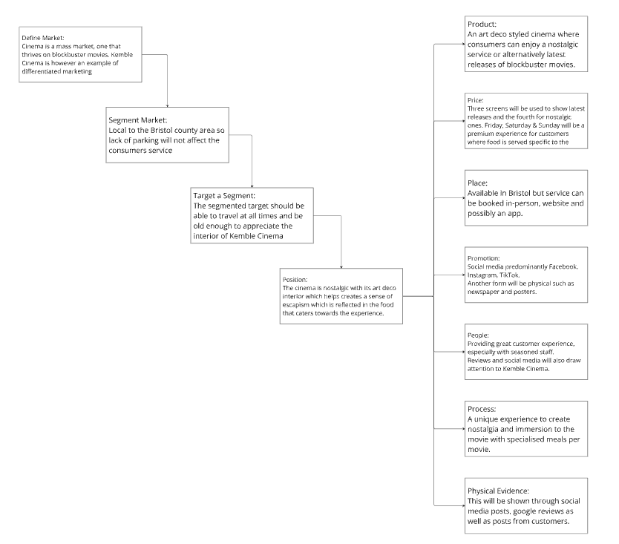
Figure 7 - STP Process
Finally, the recommended marketing audit can be best represented following McCarthy’s STP Process, which was later developed by Booms and Bitner to include the final 3Ps. The Product Kemble Cinema offers is the unique nostalgic service which is an alternative to the modern traditional way to enjoy cinema, which Kemble will continue to with their three remaining screens. Pricing will differ between services; the latest releases will be lowered to match competitors, and specialised classic events will be held at a premium as food will be included in the package, but drinks will be separate to increase sales.
Kemble Cinema still remains local to Bristol and its services will be available to book via the website or in-person. Promotion of the service will be achieved predominantly through social media such as Facebook, Instagram and Tik Tok. While other digital avenues could be explored such as TV due to it being the highest consumed form of media for the segmented generations (Ofcom, 2024), it is possibly beyond the funding Kemble Cinema can provide. Alternatively/simultaneously, physical advertisement in the form of newspaper and posters can be used to market specifically to Bristol or mail to local housing estates near Kemble Cinema.
Great customer experience from seasoned staff can create positive public perception which is supported by reviews and social media attraction from customers. The Process behind Kemble Cinema will be its unique experience which will have Physical Evidence provided for it through the form of social media posts, google reviews as well as posts from customers.

Evaluation
Success of similar ideas can be seen with Taste Film a successful example of a blue ocean company, which provides a unique cinema experience where the food and drinks shown on screen are presented to customers throughout the duration of the movie. Taste Film since its creation five years ago has accumulated partnerships with top brands such as Disney and Sky Cinema as well as being a viral hit across social media, generating masses of earned media for the brand. The recommended product concept for Kemble Cinema therefore has successful market experience and evidence as a viable option. Taste Film is currently operating in London and Manchester thus leaving the South-West available for such a unique experience to be provided by an external company.
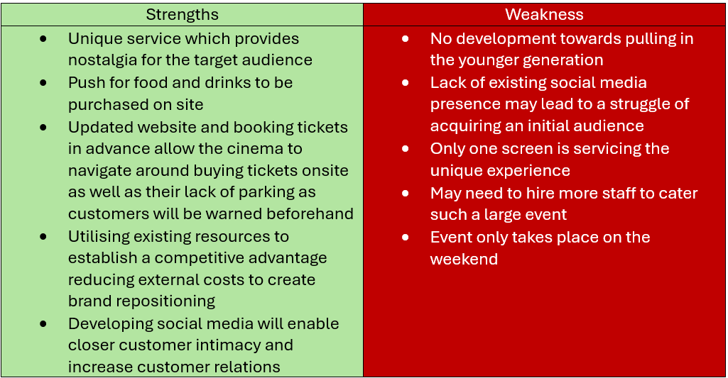
Figure 8 - Strength and Weaknesses of Marketing Strategy
Similar to Taste Film, Kemble Cinema will provide a unique service which can create nostalgia and immersion for audiences, the marketing strategy heavily favours the older generation due to the internal structure and design of the cinema itself. This results in no development towards pulling in the younger generation, who still remain the biggest audience to attend cinema. While some measures have been taken to persuade a more youthful audience to attend such as reduced ticket prices for regular blockbuster showings and the availability of booking online, accessibility improvements may not be enough to persuade younger audiences to attend Kemble Cinema.
Additionally, attracting an audience initially will be difficult due to the lack of existing social media presence, this may require new specialised staff to be hired to manage the website and social media accounts as well as additional staff to potentially manage the increase in customers for the event days. These main days, while the biggest selling point also suffer due to them only being available Friday-Sunday. These days were chosen as the audience will be free due to it being the weekend. While this could potentially be increased to Thursday-Sunday, one extra day may not lead to a big increase in sales in the long term as well as possibly affecting team morale due to exhausting days. Instead advertising as a one-time limited event could potentially boost sales in comparison.
Finally, Kemble Cinema is utilising its pre-existing assets to create a new service allowing the company to save in its development. However, the equipment is specific to one of four screens so while it is not the weekend, possible revenue gained from that fourth screen is potentially lost, this could perhaps be alleviated by allowing the public to rent the screen, but ultimately the cinema is down to three screens during the weekdays.

Question 2
Select one theory/framework/concept that you have applied in answering question one. Assess its strengths and limitations for strategic marketing planning both in the context of the Kemble Cinema case study, and in the context of the Nespresso case study that was studied in class.
The blue ocean theory developed by Kim and Mauborgne in 2004 was utilised to identify the strategic position Nespresso took at the beginning of its lifetime. Nespresso benefited from first-move advantage allowing itself to build a significant competitive advantage that it maintains to this day. Similarly, Kemble Cinema will be looking to emulate such a move in an already saturated red ocean market. While moving towards a blue ocean can create a new demand with a unique selling point as showcased by Nespresso, it inevitably creates Market Challengers and Market Followers. Nespresso currently suffers from competition in the market having to perform a flank defence strategy to cover its weak spots Market Challengers may be trying to capitalise on. The Blue Ocean theory requires constant innovation to create or maintain a competitive advantage in the market, however with so many products being released this can prove to be a challenge as there is always innovation from competitors and other Blue Ocean companies.
Although a Market Leader such as Nespresso could potentially purchase smaller innovative firms on the rise to create more Blue Ocean space, smaller companies such as Kemble Cinema will unfortunately be positioned within this blue ocean until it eventually becomes a red ocean. While a blue ocean approach can be performed numerous times due to innovation always being available, for smaller firms the innovation may not work and therefore leads to a lack of growth from a potentially expensive investment. While Kemble Cinema was fortunate to have the resources available, many companies looking to explore a blue ocean face a risk of failure. Furthermore, entering a new market which hasn’t been established means there is no data to reinforce the notion of remarketing, it is effectively a high-risk solution to a red ocean that may lead to high rewards or low profit.
Moreover, the Blue Ocean theory is inherently simple, it has one instruction which is to move to a position in the market that has little competition. It does not provide a detailed strategy or effective plan for companies to utilise through their journey from the red to the blue ocean. This can be seen with the case of Nespresso who were initially a unique selling point in their market but has failed to develop a perfect plan and is now performing defensive actions from its competitors. Similarly, Kemble Cinema has moved to a new Blue Ocean market which has one strong Market Leader in Taste Cinema but is otherwise void of competitors. However, Kemble Cinema in the future will suffer from lack of innovation as it either runs out of movies or the aging audience loses interest in the product.
Therefore, the Blue Ocean theory requires a more intricate framework outside of its Four Action Framework. To effectively use the blue ocean framework companies will need to utilise accompanying frameworks such as the Ansoff Matrix to help companies identify whether they are initially in a red ocean and should explore the possibility of a blue ocean and whether the benefits of moving to a blue ocean environment is the best solution for the company. Companies moving to a blue ocean should have a clear guiding system to aid in their move and evaluate whether they have successfully entered a blue ocean as there is no defined way to assert whether a company is in one besides a competitive advantage.

Appendix
SWOT Analysis:
Strength:  - Unique cinema experience  - Still has the equipment for 35mm and 70mm film projection  - Full bar and café offering a much broader range of food than most cinemas  - Warm and friendly staff (who have worked for Kimble Cinema for many years) provide a good service and experience  - Showcases mainstream blockbuster films  - Art deco style  - Cinema with a history  - Part of local community | Weakness:  - One cinema site with 4 screens in comparison to bigger competitors  - No onsite parking  - Competitors have more modern resources such as improved video projections and sound equipment  - Competitors have better marketing promotion and website  - Estimates of 25% of food and drink consumed in the cinema is not bought on site  - Viewed as 'old-fashioned' which deters a younger audience  - Expensive viewing in comparison to competitors  - Kemble Cinema only has a basic website and Facebook page with no app
Opportunities:  - Resurgence of vinyl records could be a revival of 35mm and 70mm film projection  - Unique art deco style which is niche for the sector  - Earned promotion through loyal customers  - Just like the resurfacing of vinyl and old records the cinema can show past movies  - People use cinema as an escapism activity which has seen an increase in COVID especially for solo cinema viewership  - Market leaders are filing for bankruptcy and being taken over by other market leaders | Threat:  - Movies spend less time in cinemas before transitioning to DVD or streaming services  - Ticket prices have gone up due to inflation  - Multiplex chains may acquire arthouse cinemas  - Customer frequency has decreased - young audience is not visiting the cinema (biggest audience to attend cinemas)  - Less blockbuster movies being released into cinemas  - Inevitable drop of visitors after COVID which hasn't recovered  - People prefer to book online or via an app rather than find a ticket in-person to guarantee desired seat  - Many people who attend the cinema are not likely to purchase food from the cinema perhaps linked to cost-of-living, however if the food is associated with health, it has a higher chance of purchase, especially from dual-parent families - 25% of food and drink consumed in his cinema is brought in rather than purchased on site

Macroenvironment, Mesoenvironment, Microenvironment
Macro | Meso | Micro
- Recovery from the COVID-19 pandemic  - Cost of living crisis hinders market recovery as people cutback on leisure spending  - Many people who attend the cinema are not likely to purchase food from the cinema perhaps linked to cost-of-living, however if the food is associated with health it has a higher chance of purchase, especially from dual-parent families  - People prefer to book online or via an app rather than find a ticket in-person to guarantee desired seat  - 59% of people enjoy frequenting the cinema alone and can be a positive 'me-time.  - Improvement in video projection quality, audio quality and lighting quality | - Less blockbuster movies being released into cinemas  - Cinema companies are filing for bankruptcy  - Market leaders have a strong hold on the percentage of people attending screens  - Customer frequency has decreased  - There is a big percentage of customers supplying their own food and drinks  - The younger generation is the biggest customer market using it as a place to meet friends, however the biggest increase in users has been Gen X, which is linked to the release of nostalgic series  - Video streaming services acquiring movies shortly after cinema release - the traditional 17 week 'theatrical window' between films in cinema and DVD has shortened due to streaming channels  - Bristol is a city full of powerful multiplex cinema chains and single-screen independents that specialise in art house films - which are also being acquired by multiplex chains  - Streaming services are now funding their own movies to have exclusive rights to the viewership | - 1938 Art Deco Style cinema which is family run and part of the local community  - Still has the equipment for 35mm and 70mm film projection  - 4 Screens each with a capacity of 100 people - one screen has non-traditional set-up with sofas and tables for food and drinks rather than fixed seating  - Showcases mainstream blockbuster films  - 25% of food and drink consumed in his cinema is brought in rather than purchased on site  - Struggles to attract younger audiences because of location in a quiet suburb rather than a retail park - viewed as 'old-fashioned'  - The cinema has a basic website and Facebook page - no app  - More expensive than multiplexes, no car park  - Full bar and cafe offering a wide range of food  - Warm and friendly staff provide a good service and experience - reliant on customer loyalty but doesn't do anything to maintain or encourage loyalty

TOWS Analysis
 | Strengths:  S1. Unique Cinema Experience with art deco style that is still equipped with 35mm and 70mm video  S2. Wide range of food and drinks not typically found in a cinema | Weaknesses:  W1. No app and basic social media & website  W2. No onsite parking  W3. 25﻿% of food and drinks brought to the cinema are external
Opportunities  O1. Resurgence of Vinyl and sequels to old blockbuster movies showcase possibility for nostalgia  O2. People use cinema for a sense of escapism which has risen since COVID | The resurgence of vinyl indicates people are seeking nostalgia, cinema can achieve this with rereleases of old movies or older video projections.  Escapism can be enhanced with non-traditional food and drinks. | Developing a social media presence to showcase the vintage style of the cinema.  Buying tickets online will aid in the escapist feel as it enables people to not be interrupted while at the venue.
Threats:  T1. Less blockbuster movies are currently being released - spend less time in cinemas before going on DVD and streaming services  T2. People prefer to book online than in-store - also buy less food due to cost-of-living | Offer a complete unique experience that is a nostalgia blast. Utilising the classic video projections to relive old movies on the big screen with food and drinks potentially related to the show.  Alternatively sell more healthy food to decrease the negative feeling of buying. | Develop social media and website as well as the creation of an app for ease of booking.  Booking in-advance can counter the lack of parking due to people knowing how to get there prior to arriving on the day.

Marketing Audit
Product | An art deco styled cinema where consumers can enjoy a nostalgic service or alternatively latest releases of blockbuster movies.
Price | Three screens will be used to show latest releases and the fourth for nostalgic ones. Friday, Saturday & Sunday will be a premium experience for customers where food is served specific to the featured nostalgic movie.
Place | Available in Bristol but service can be booked in-person, website and possibly an app.
Promotion | - Social media predominantly Facebook, Instagram, TikTok.  - Another form will be physical such as newspaper and posters.
People | - Providing great customer experience, especially with seasoned staff.  - Reviews and social media will also draw attention to Kemble Cinema.
Process | A unique experience to create nostalgia and immersion to the movie with specialised meals per movie.
Physical Evidence | This will be shown through social media posts, google reviews as well as posts from customers.

References
Ansoff, H. (1965) Corporate Strategy. New York: McGraw-Hill.
Barney, J. (1991). Firm resources and sustained competitive advantage. Journal of Management, 17(1), 99–120.
Bellaouaied, M. (2024) STP Process Material. Customer Behaviour [online]. Available from: https://blackboard.uwe.ac.uk/ultra/courses/_364589_1/cl/outline [Accessed 02 October 2024].
CIM (2015) A brief summary of marketing and how it works. Marketing and the 7Ps [online]. pp. 1-12. [Accessed 01 October 2024].
Davidson, J. (1987) Offensive Marketing. Harmondsworth: Penguin.
Hawker, K. (2019) Keller’s Brand Equity Model – What It Is & How to Use It. Medium [blog]. 26 September. Available from: https://medium.com/@keatonhawker/kellers-brand-equity-model-what-it-is-how-to-use-it-84e42d562299 [Accessed 30 December 2024].
Kim, W. and Mauborgne, R. (2005) Blue ocean strategy: From theory to practice. California Management Review. 47 (3), pp. 103-122.
Kozlenkova, I., Samaha, S., and Palmatier, R. (2013) Resource-based theory in marketing. Journal of the Academy of Marketing Science, 42 (1), 1-21.
Liang, B. (2024) Study unit 5 STP. Marketing Strategy [online]. Available from: https://blackboard.uwe.ac.uk/ultra/courses/_364590_1/cl/outline [Accessed 30 October 2024].
McGrath, R. (2022) Cinemas – UK – 2022, Mintel (2024 Version) [online]. Available from: https://clients.mintel.com/content/report/cinemas-uk-2022?fromSearch=%3Fargs%3D%252Fhomepages%252Fdefault%252F%26freetext%3Dcinema%26start%3Dredirect%26resultPosition%3D1 [Accessed 30 December 2024].
Ofcom (2022). Adults’ Media Use and Attitudes report, Ofcom (2022 Version) [online]. Available from: https://www.ofcom.org.uk/siteassets/resources/documents/research-and-data/media-literacy-research/adults/adults-media-use-and-attitudes-2022/adults-media-use-and-attitudes-report-2022.pdf?v=327649 [Accessed 05 January 2025].
Ofcom. (2024). Gen Z swerves traditional broadcast TV as less than half tune in weekly. Media use and attitudes [online]. [Accessed 04 January 2025].
Porter, M. (1980) Competitive Strategy. New York: Free Press.
Shergill, N. (2024) Film and Cinema – UK – 2024, Mintel (2025 Version) [online]. Available from: https://clients.mintel.com/content/report/film-and-cinema-uk-2024?fromSearch=%3Ffreetext%3Dcinema%26resultPosition%3D1 [Accessed 06 January 2025].
Taste Film (2025) Taste Film. Available from: https://tastefilm.co.uk/ [Accessed 06 January 2025].
Tonks, G. (2009) Validity and the design of market segments. Journal of Marketing Management, 25, (3/4), 341-356.
Treacy, M. and Wiersema, F. (1993) Customer intimacy and other value disciplines. Harvard Business Review. February, 84-93.
Weihrich, H. (1982) The TOWS matrix – A tool for situational analysis, Long Range Planning, 15 (2), 54-66.

